Introduction to multiple steps’ approach

This approach referenced the code from link: <https://machinelearningmastery.com/multi-step-time-series-forecasting-long-short-term-memory-networks-python/>

# Prepare data

In this approach, a rolling-forecast scenario will be used, also called walk-forward model validation.

We will get the last 28 day’s prediction data, under the following format:



First, split the dataset into training set and testing set.

The training dataset is like follows (top 20 lines):



The testing dataset is like follows:



Time-differenced and scaled training dataset and testing dataset is like follows:



# Determine number of neurons

We control the randomness of the code, to lookup the most appropriate number of neurons:

30-epoch turns’ result:

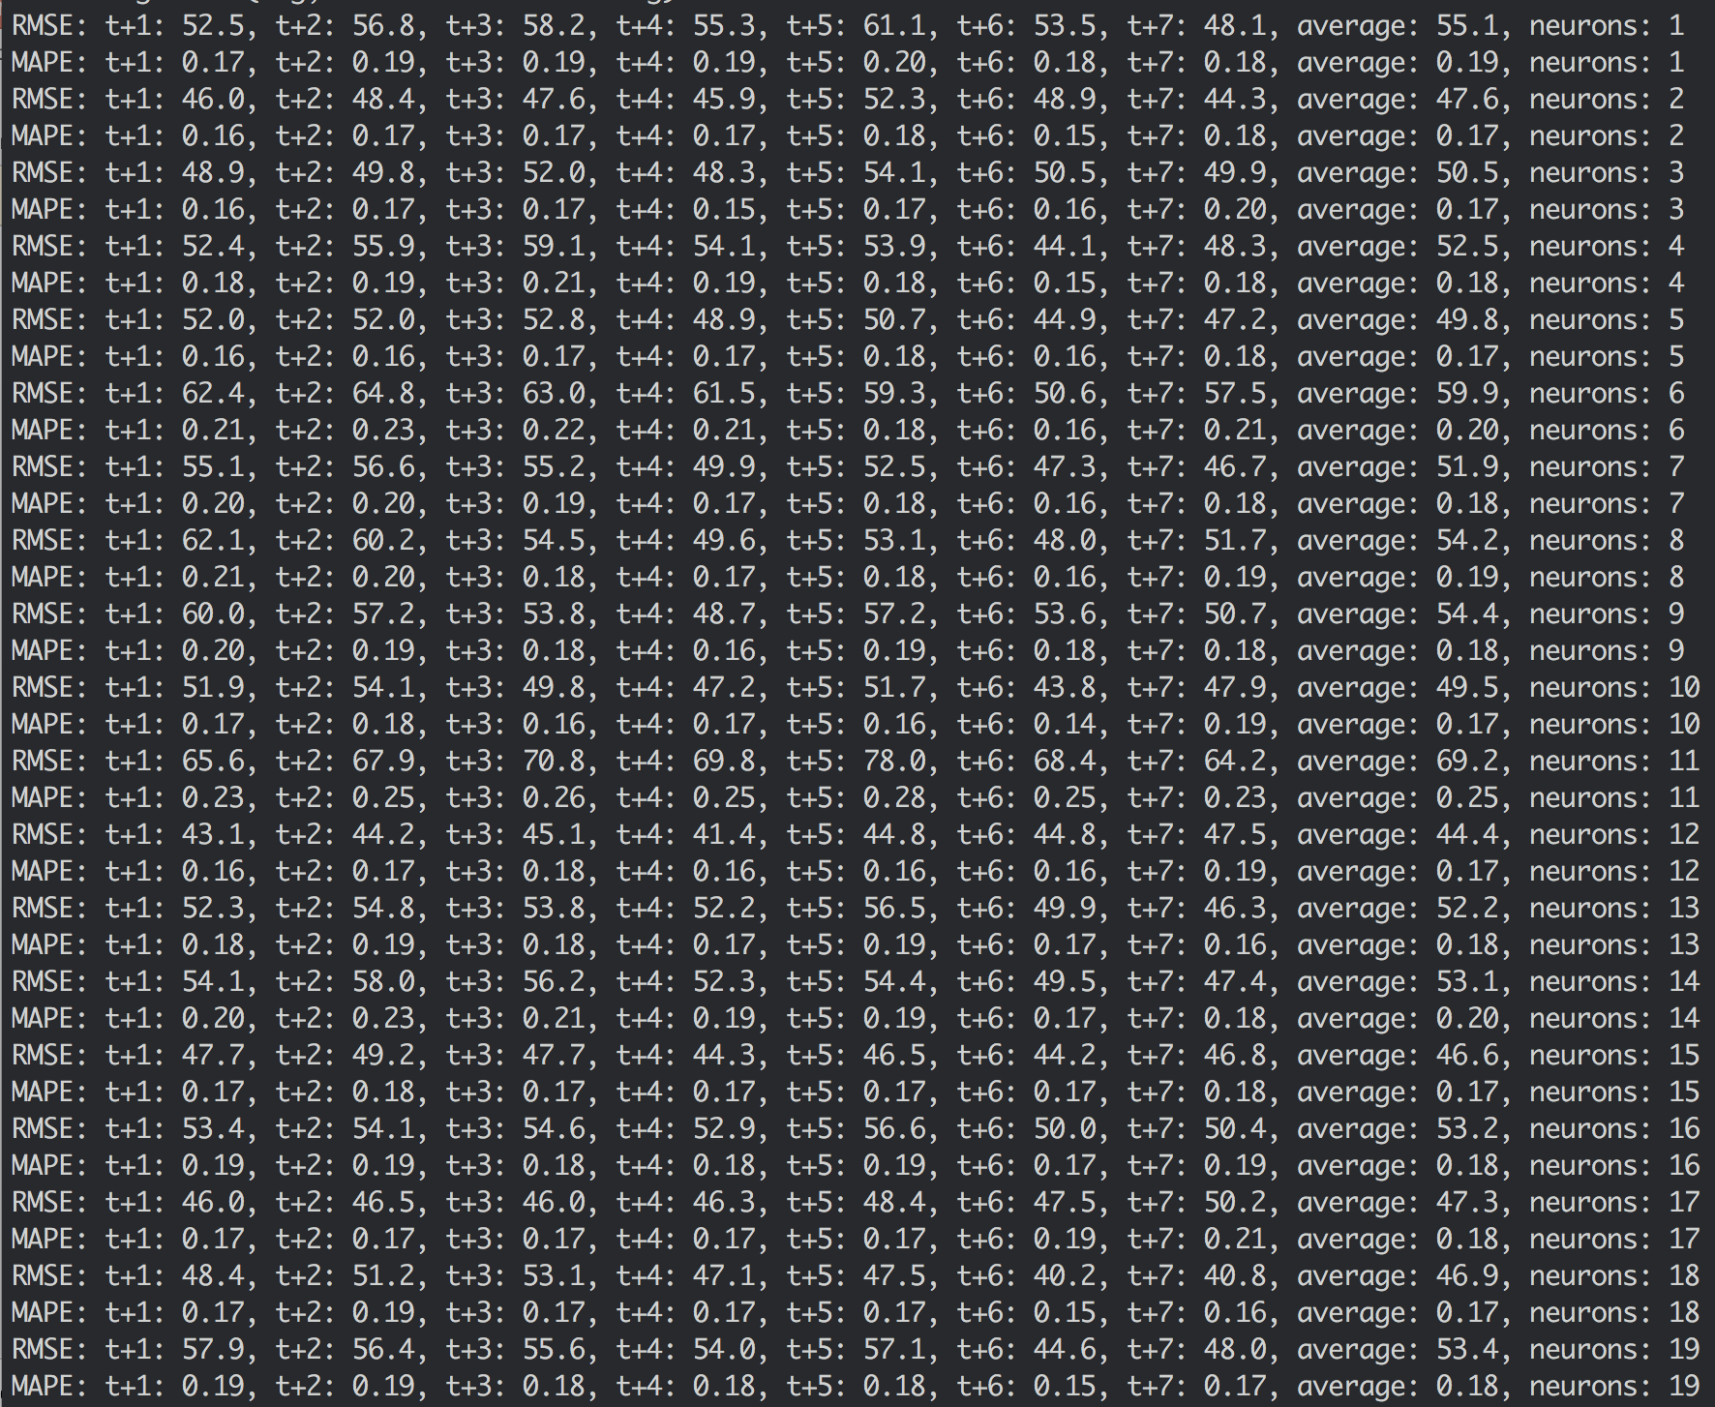

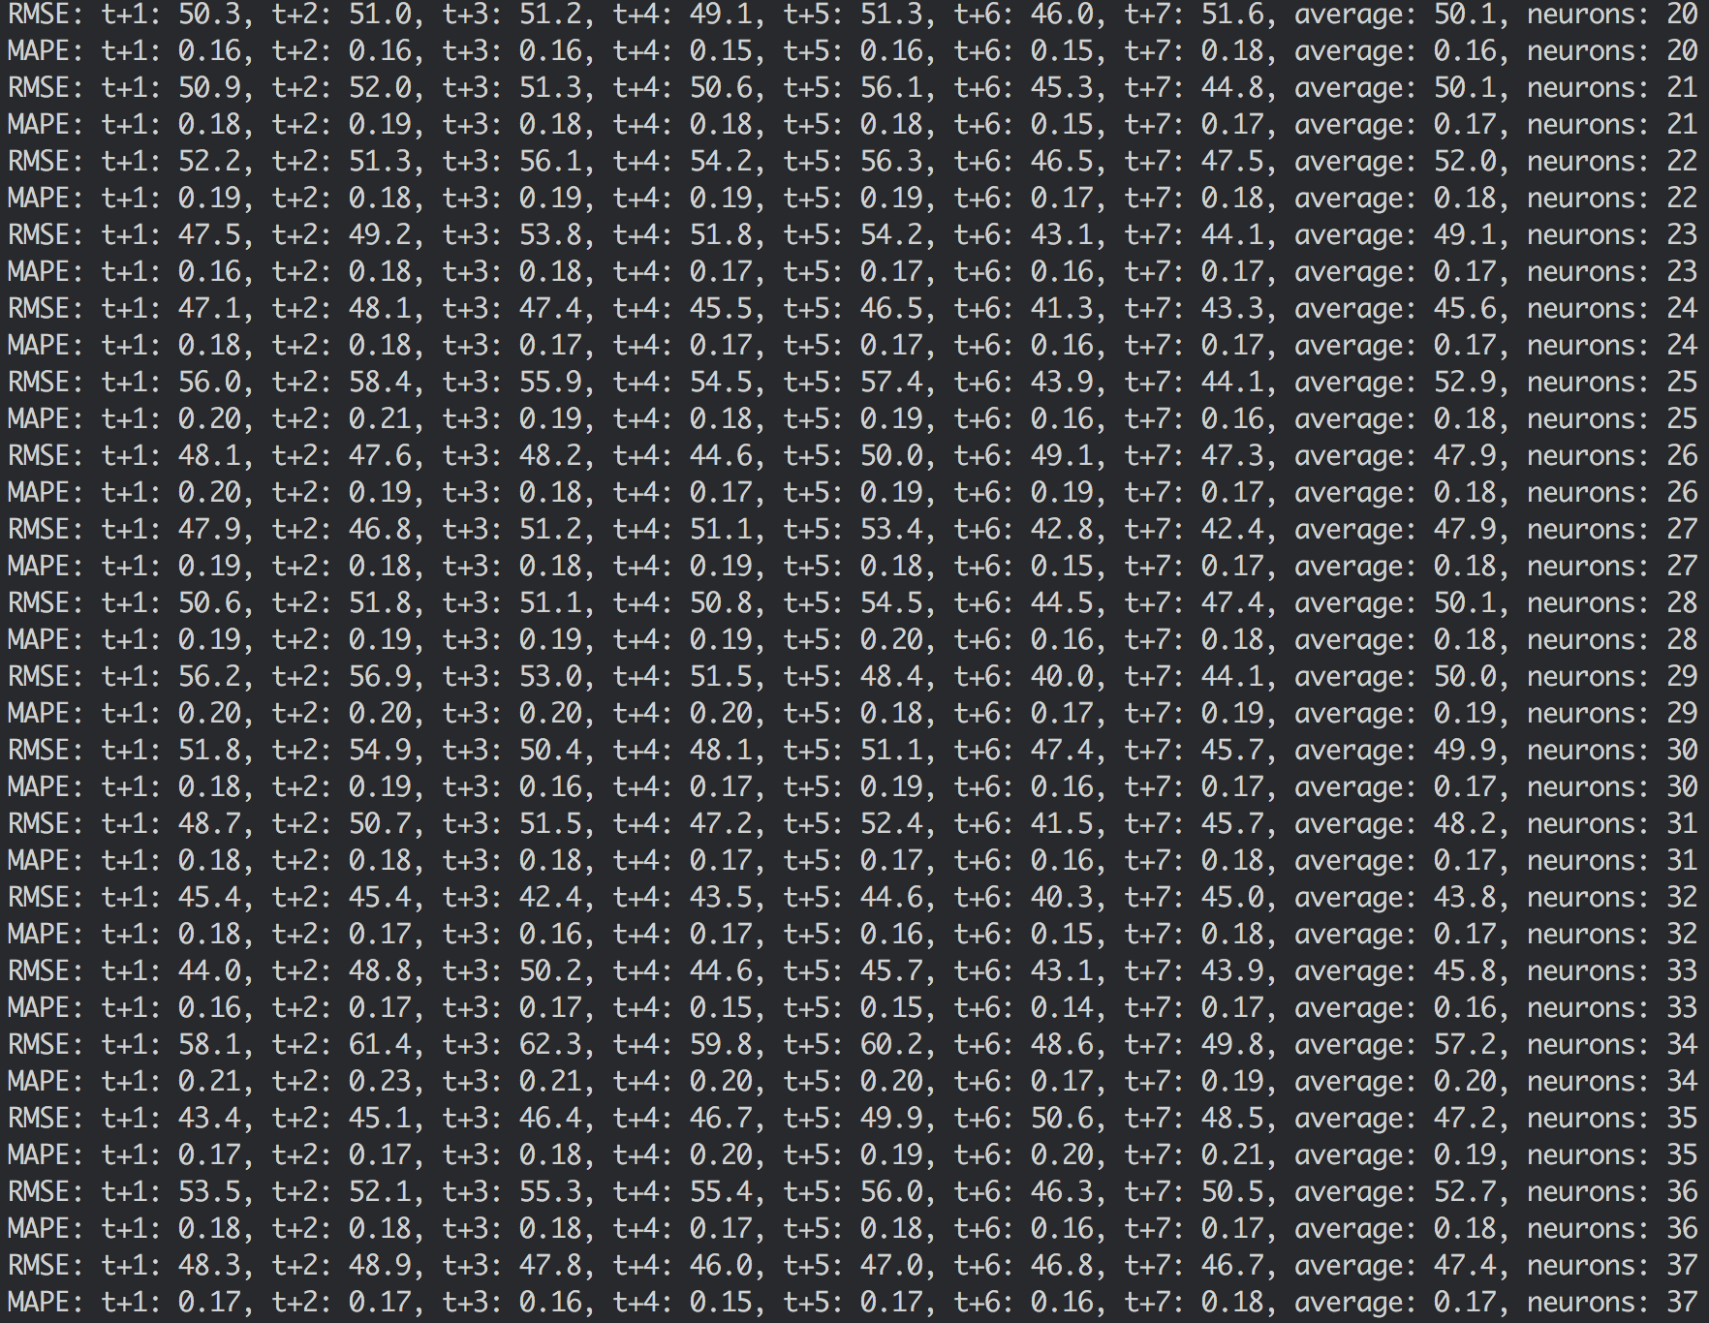

200-epoch turns’ result:

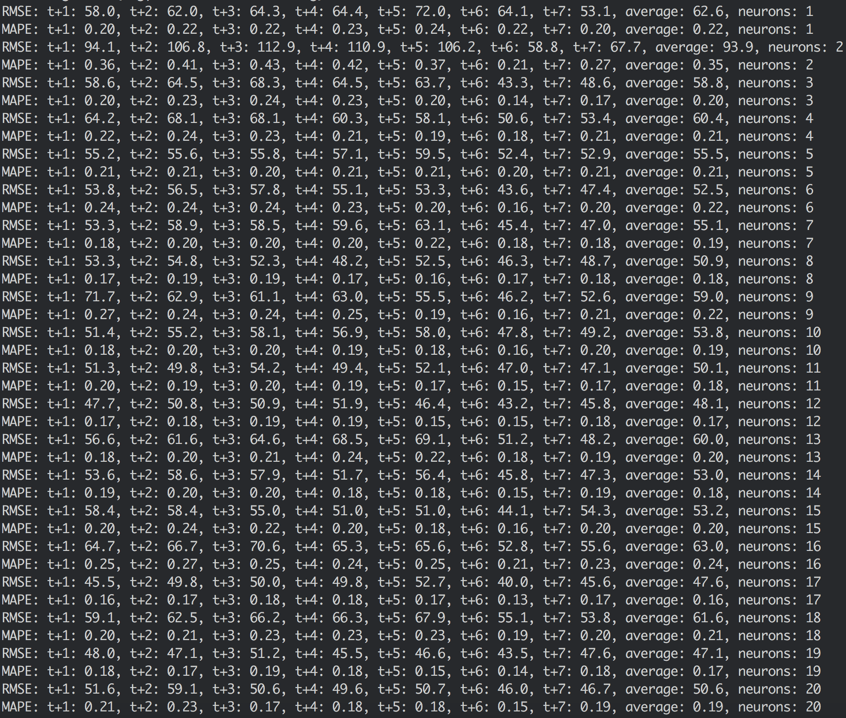

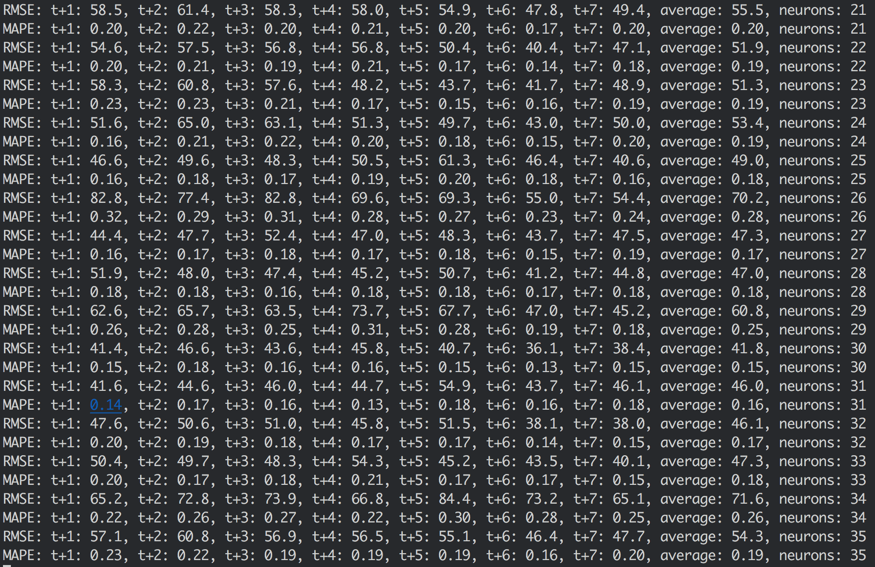

Like one-step’s forecast, it seems that the performance is the best when the number of neurons is equal to 30, so we choose the number of neurons to be 30.

# Make forecast

We recover the randomness of the code, and make a one turn forecast (30 porch’s training), using mstep.py, the result is as follows:



We got 7-day forecasts, the comparison of real data and forecast data is shown as below (10 day’s data, real data shown in blue color):



Now let we make a 30-turn forecast (200 epoch’s training each turn), using mstep_30_turn.py, the result is as follows:

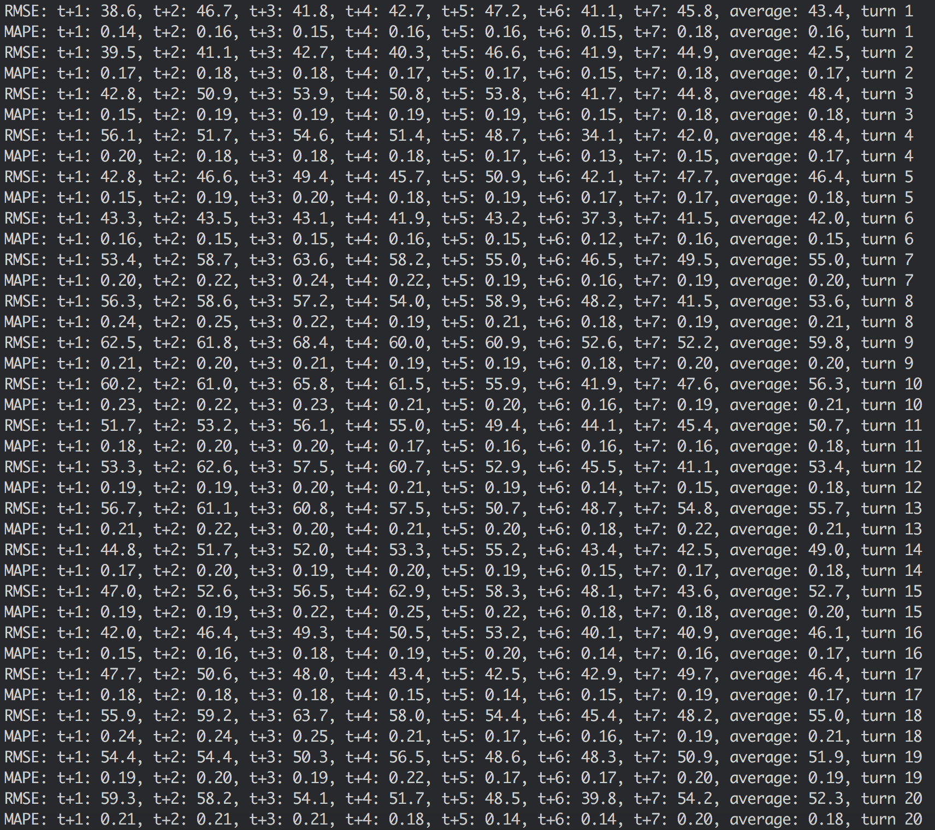

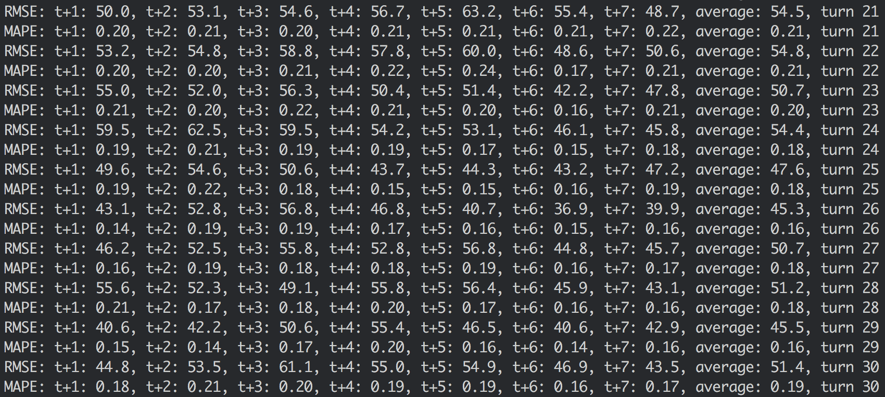

The description of RMSE data is as follows:

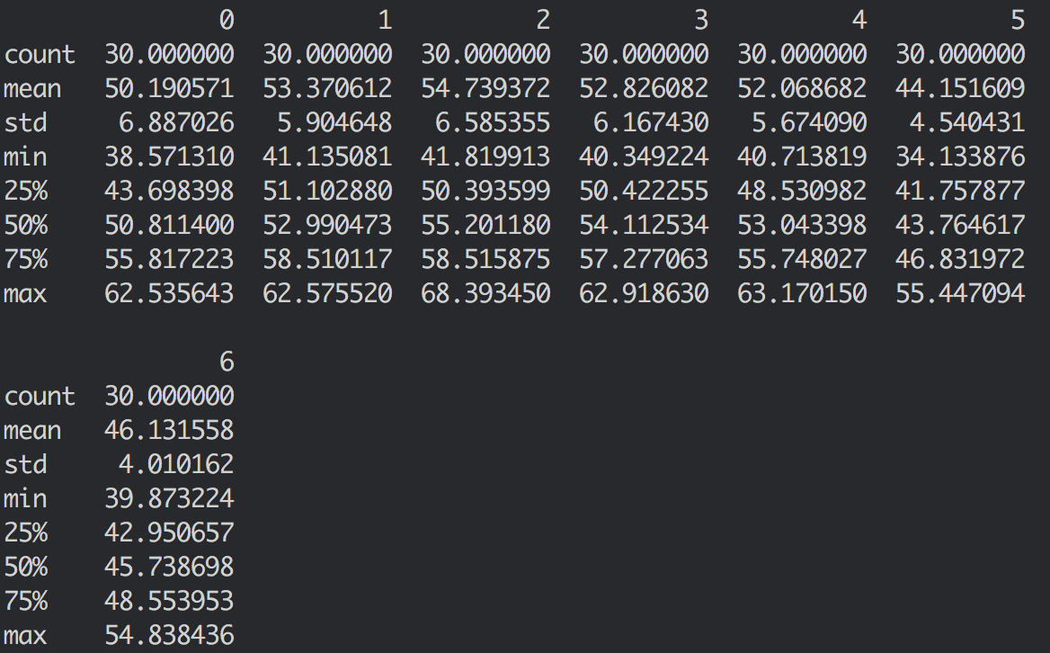

The description of MAPE data is as follows:

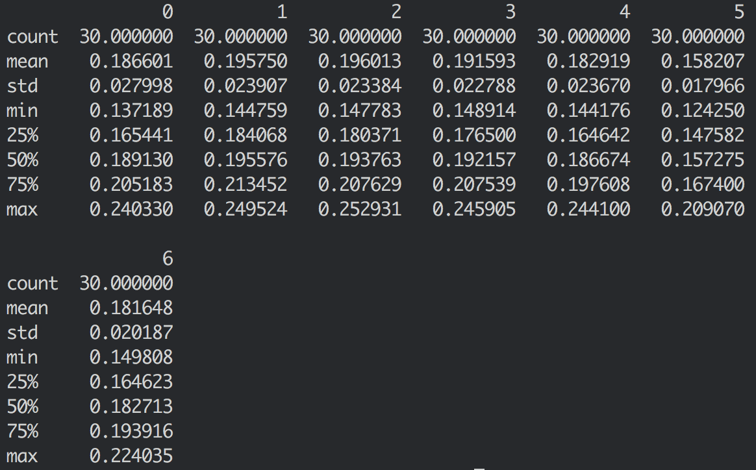

Plot of RMSE data distribution:

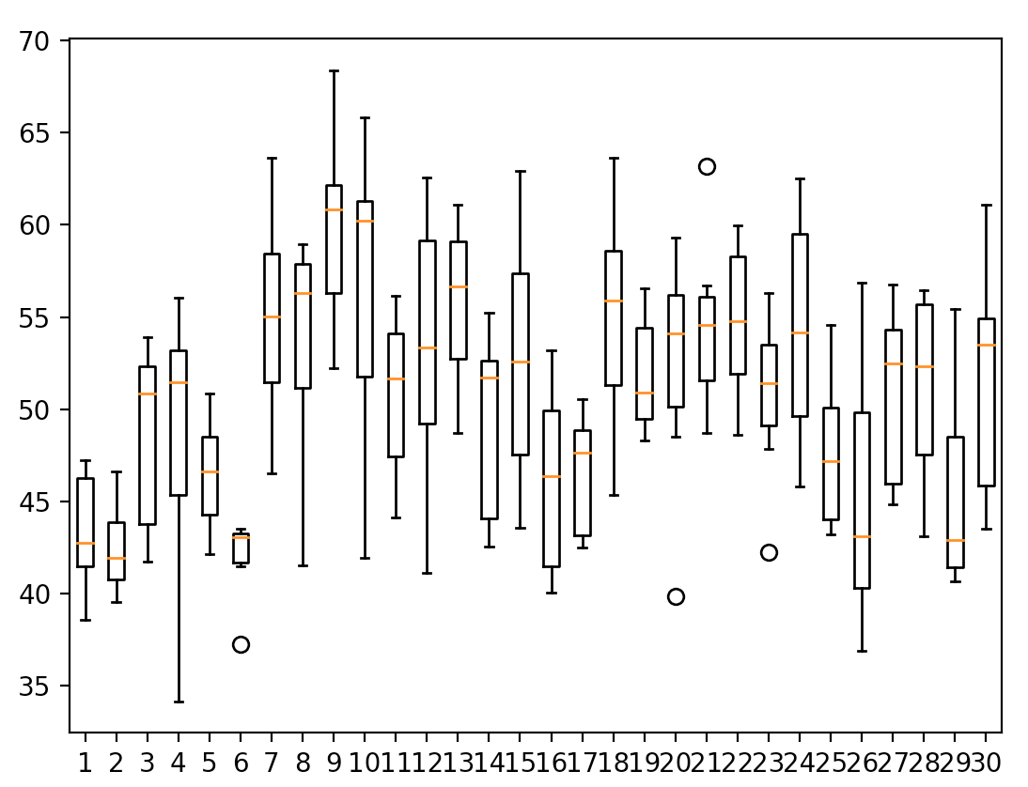

Plot of MAPE distribution:

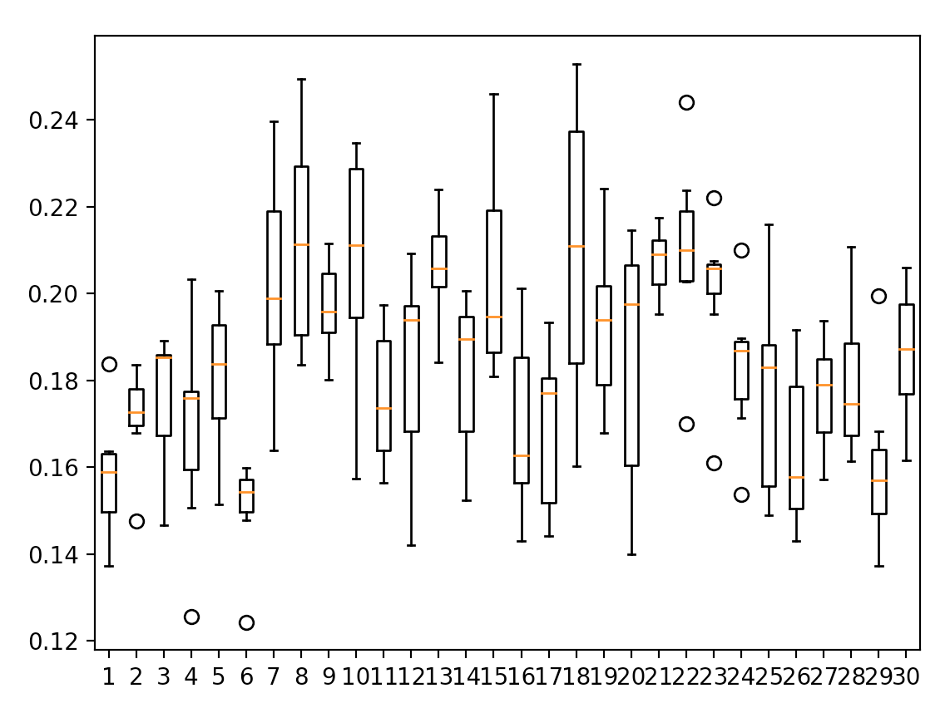

# Conclusion

It seems strange that, how can the multiple steps’ forecast be more accurate than one step’s forecast?

My understanding is because the effectiveness of the training dataset. In each line of the multi-step’s training dataset, there are much more information than single-step’s, and all of these give much more trajectories to follow.